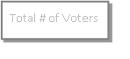
[MUNICIPAL NAME] ELECTION RECORD – [ADVANCE POLL OR ELECTION DAY, [DATE] – [WARD/POLLING DIVISION (if applicable)]
Consec  No. | NAME OF ELECTORS | ADDRESS | Ballot Issued  Council | Ballot Issued Mayor | NOTES  (list declaration(s) made, changes to elector information, etc.)

